**DBMS Lab Assignment 3B**

**Neeti Kurulkar**

**Problem Statement:** Perform at least 10 SQL Subqueries.

**Queries**:

1. Write a SQL query to find those employees who receive a higher salary than the employee with ID 163. Return first name, last name.

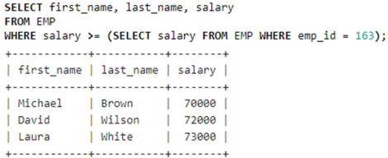

1. Write a SQL query to find out which employees have the same designation as the employee whose ID is 169. Return first name, last name, department ID and job ID.

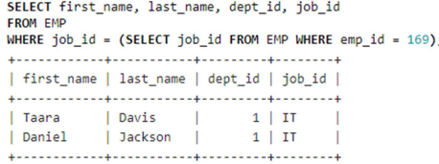

1. Write a SQL query to find those employees whose salary matches the lowest salary of any of the departments. Return first name, last name and department ID.

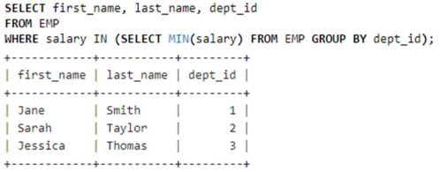

1. Write a SQL query to find those employees who earn more than the average salary. Return employee ID, first name, last name.

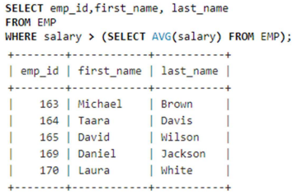

1. From the following tables, write a SQL query to find all those employees who work in the Finance department. Return department ID, name (first), job ID and department name.

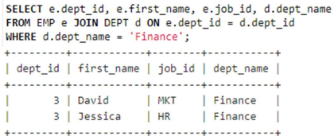

1. Write a SQL query to find the employee whose salary is 62000 and the reporting person’s ID is 121. Return all fields.

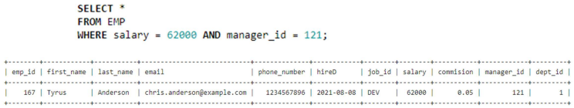

1. Write a SQL query to find the employee whose salary is 62000 and the reporting person’s ID is 121. Return all fields. Write a SQL query to find those employees whose ID matches any of the numbers 164, 169 and 183. Return all the fields.

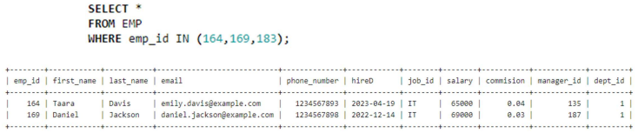

1. Write a SQL query to find those employees whose salary is in the range of 65000, and 70000 (Begin and end values have included.). Return all the fields.

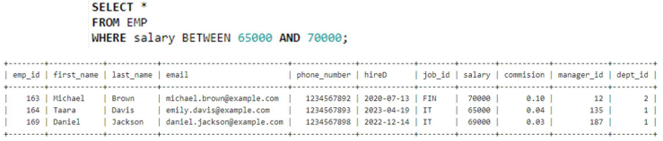

1. Write a SQL query to find those employees whose salary falls within the range of the smallest salary and 60000. Return all the fields.

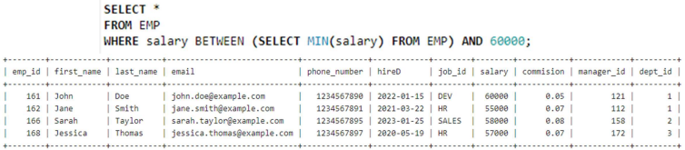

1. Write a SQL query to find those employees who get the second-highest salary. Return all the fields of the employees

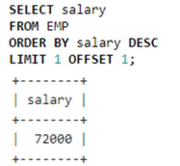

1. Write a SQL query to find those employees who work in a department where the employee’s first name contains the letter 'T'. Return employee ID, first name and last name.

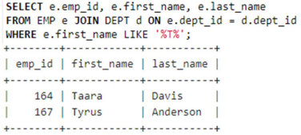

1. Write a SQL query to find those employees whose department is located at ‘Toronto’. Return first name, last name, employee ID, job ID.

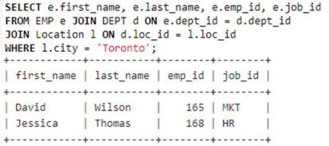

1. Write a SQL query to find those employees whose salary is lower than that of employees whose job title is ‘MK_MAN’. Return employee ID, first name, last name, job ID.

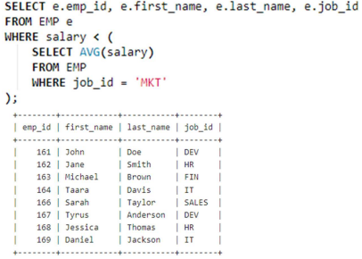

1. Write a SQL query to find those employees whose salaries are higher than the average for all departments. Return employee ID, first name, last name, job ID.

